**A Comprehensive Analysis Of Financial Performance: Insights From A Leading Banks**

Top of Form

Bottom of Form

# 1 . INTRODUCTION

## 

## 1.1 Overview

## 

## The metrics, investors and analysts can gain insights into the bank's financial health, profitability, and growth prospects, and make informed investment decisions. A comprehensive analysis of financial performance also helps identify potential risks and opportunities for the bank, which can inform strategic planning and ensure the long-term success and stability of the bank.

## 1.2 Purpose

# The purpose of conducting a comprehensive analysis of financial performance for a leading bank is to evaluate its overall financial health and performance. This involves analyzing various financial metrics and ratios to gain insights into the bank's profitability, efficiency, risk management, and capital adequacy

# 2 . Problem Definition & Design Thinking

# 

# Empathy Map

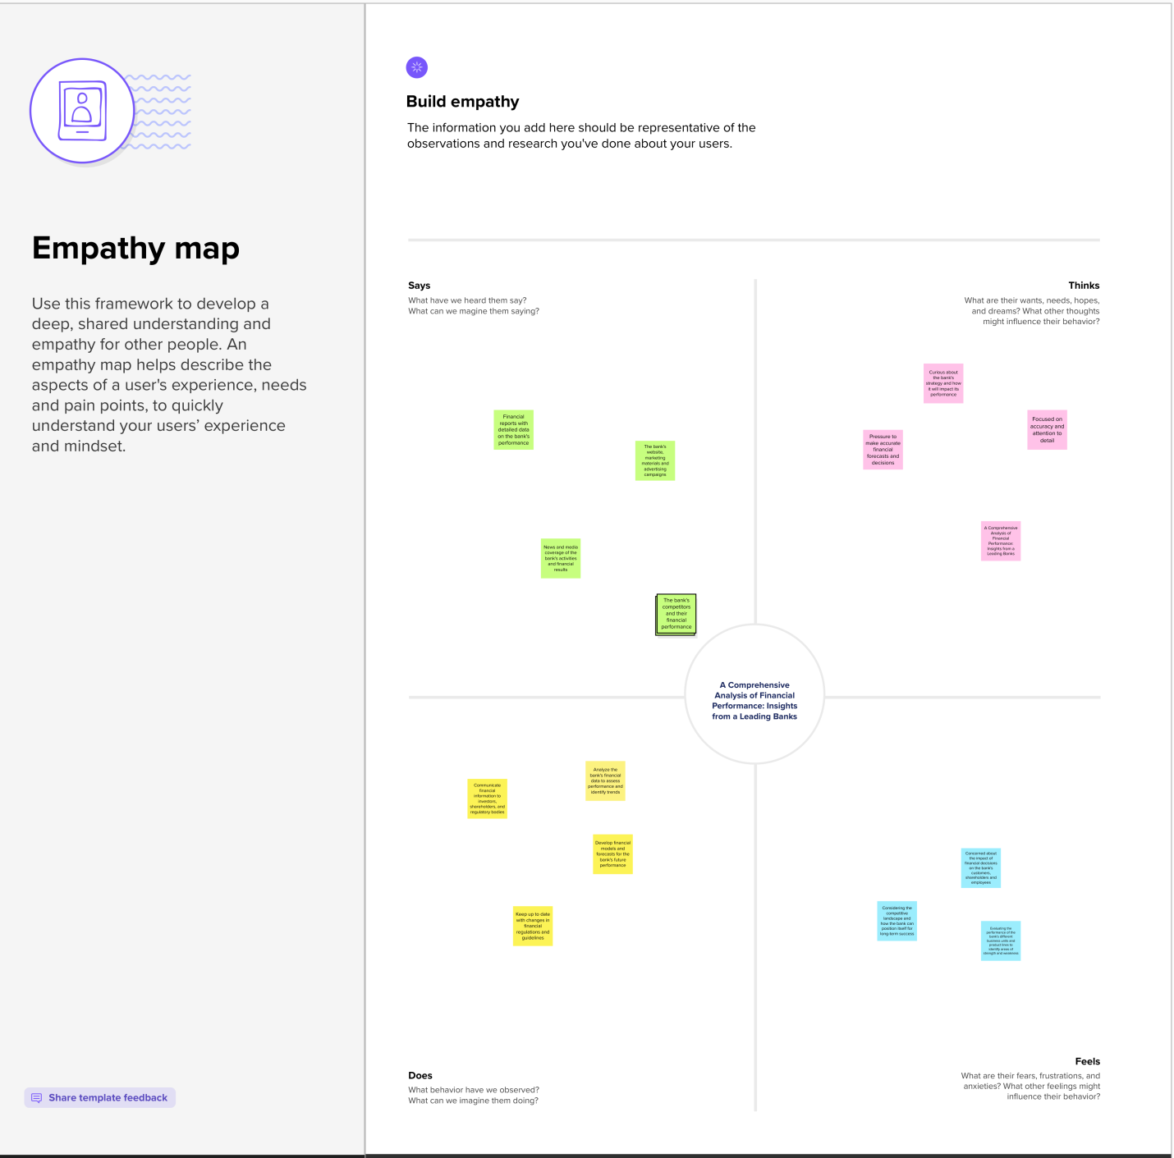

**3. Activity and screenshort**

1. Top Banks according to Rank and assest.
2. Top Bank according to country based on total assests.
3. Top 10 countries with assest proportion.
4. Country with total assest using funnel chart in increasing order
5. Total assest analysis according to year and quarter
6. Top Banks according to total assest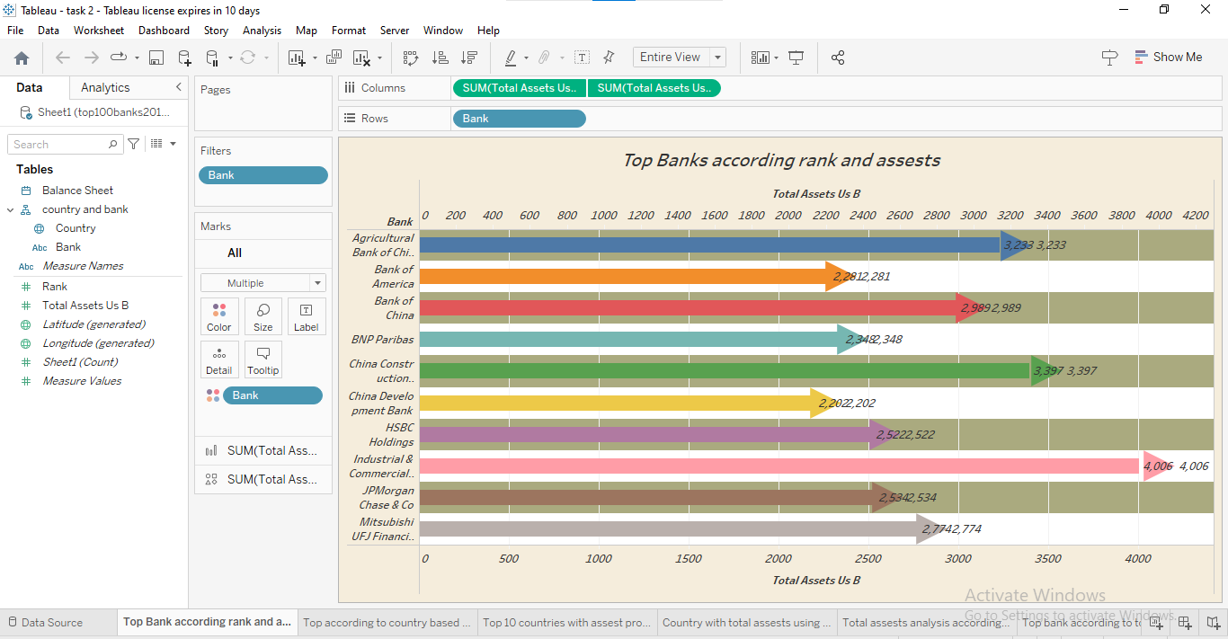

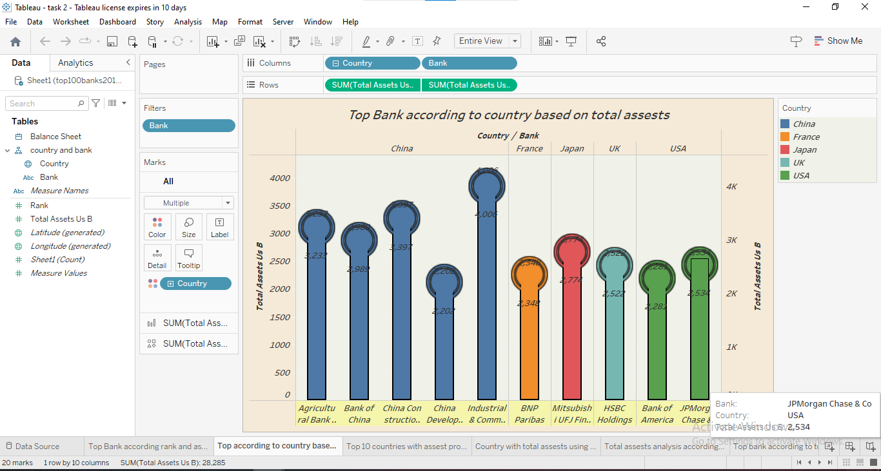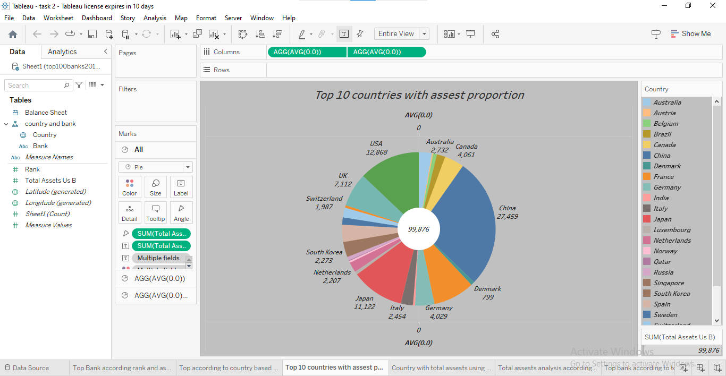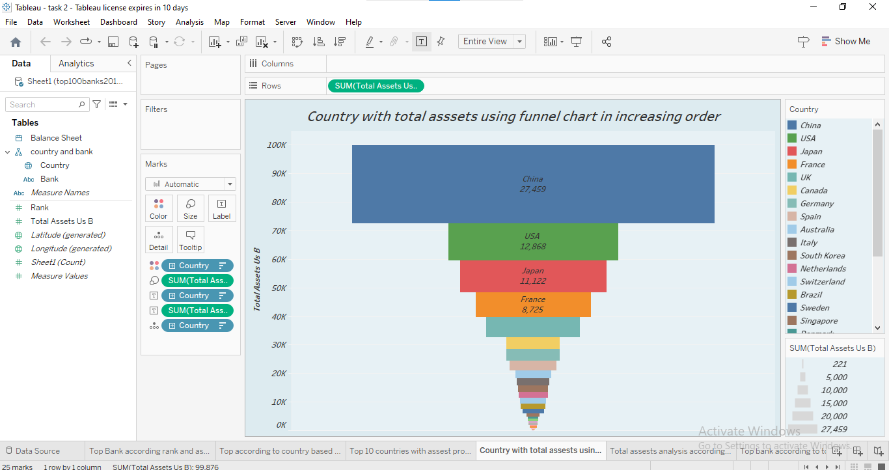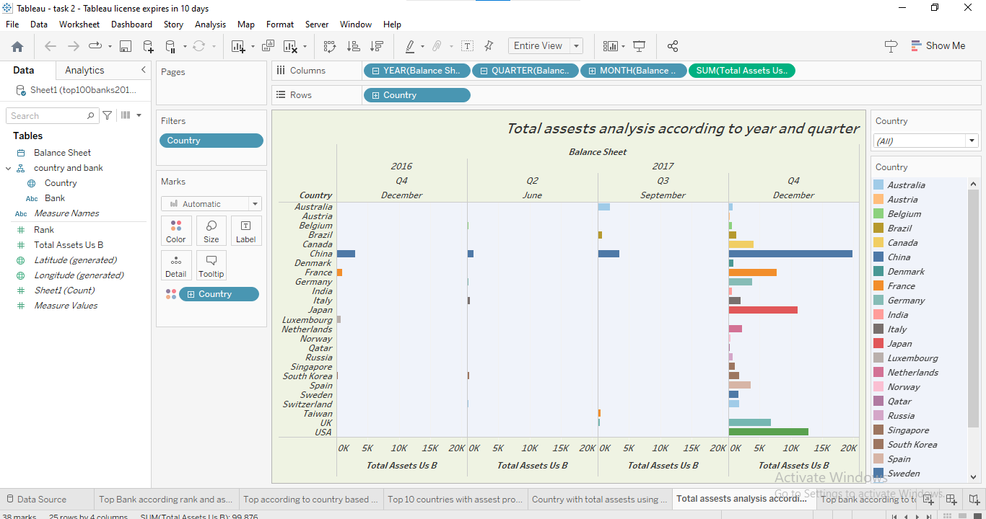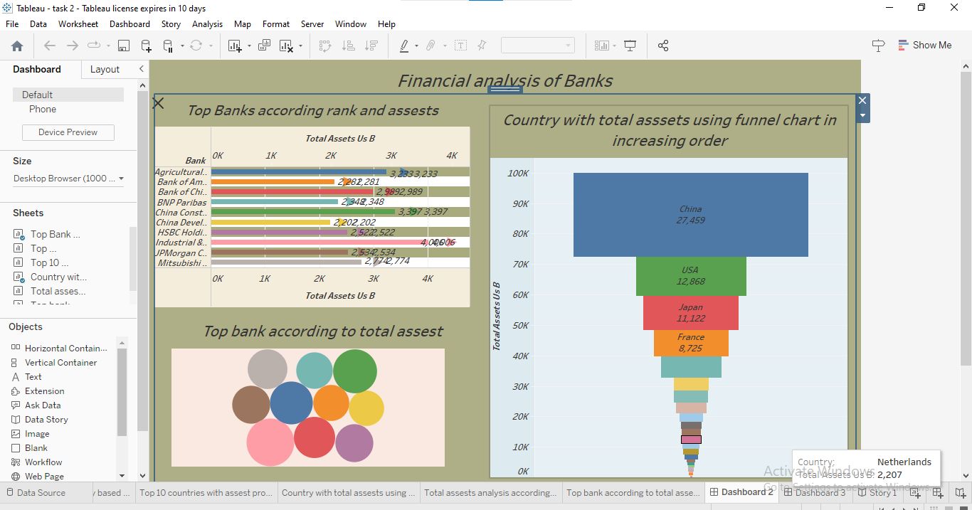

**4. ADVANTAGE**

* **Internal and external stakeholders**
* **Business health grow**
* **Assessing the profitability**
* **Evaluation of past performance**
* **Prediction of future performance**

**DISADVANTAGE**

* **Problem in comparability**
* **Reliability of figures**
* **Change in Accounting method**
* **Change of Business condition**
* **Based of past data**

**5 . APPLICATIONS**

* **Financial analysis can be used to measure a bank's profitability by examining its income statement and assessing its revenue, expenses, and net income.**
* **Financial analysis can be used to evaluate a bank's asset quality by examining its balance sheet and assessing the quality of its loans and investments**

# 6.CONCLUSION

# 

# A financial analysis of a leading bank can provide valuable insights into its financial health, strengths and weaknesses, risk management practices, and competitive position.

# These insights can be used to make informed decisions about investment, lending, and other financial activities related to the bank.

# 7. FUTURE SCOpe

* **Integration of AI and machine learning: With advancements in technology, there is an opportunity to integrate AI and machine learning algorithms into the financial analysis process**
* **Focus on environmental, social and governance(ESG) factors: There is a growing focus on ESG factors in the financial industry, and this is likely to continue in the future.**
* **Use of Blockchain technology: Blockchain technology has the potential to streamline and simplify financial transactions, which could have a significant impact on financial performance analysis.**